**Deerwalk Institute Of Technology**

**Database Administration**

**Lab:**

**Submitted By: Submitted To:**

**Name: Sagar Giri Narayan Chalise**

**Roll No. 205**

**Date:**

1. Run the script file awrrpt.sql that is present in the location of oracle home D:\oracle\product\10.2.0\db_2\RDBMS\ADMIN as following:



1. Select default parameter for generating the report:

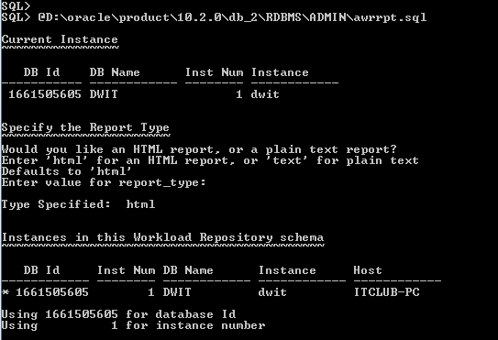

1. Select the range of the snapshots that you want to take with default parameters:

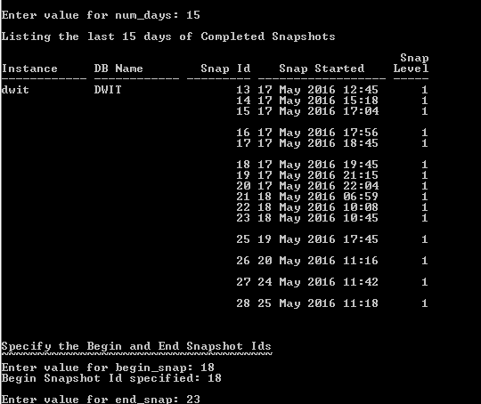

Finally the report is generated in html file as below: